**BOOKING FORM (RSVP Before 19th September 2025)**

|  |  |  |  |  |  |
| --- | --- | --- | --- | --- | --- |
| **Attendance** | **Member** | **Partner** | **Cost P.P.** | **Total** | **Menu Choice** |
| Welcome Meet and Greet Sydney Masonic Centre |  |  | $65.00 |  |  |
| Grand Installation The Sydney Masonic Centre |  |  | No Charge |  |  |
| Grand Proclamation Banquet |  |  | $90.00 |  | Alternate  Drop |
| ~~Tour and Lunch at~~  ~~Sydney Opera House~~ |  |  |  |  |  |

Rank & Name………………………….

Jurisdiction ……………………………

Conclave……………………………No...............

Email ……………………………………….

Partner’s Name…………………………

Other Guests and Ladies…………………….

**SPECIAL DIETARY REQUIREMENTS - PLEASE ADVISE**

………………………………………………

Preferred Payment:

EFT to “Grand Council OSM General Account” BSB 062-644 Acc. 00902519 (**PLEASE QUOTE YOUR NAME AS REFERENCE** ) for:

Meet and Greet @ $65 p.p. $............

Banquet tickets @ $90 p.p. $.....

~~Farewell @ $80 p.p~~. $..............

Total $ ..........

Please send forms to : **Mr. T. Harris**

**trev@shirebrewing.com**

**111 Garnet Road,**

**Gymea. NSW. 2227**

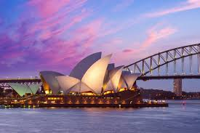**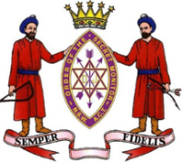  
Grand Council of the**

**Order of the Secret Monitor**

**for the Sovereign State of New South Wales   
and Australian Capital Territory**

**The Grand Supreme Ruler**Most Worthy Brother

Stephen Charles Hayne

**cordially invites you to the Installation of**

**The Grand Supreme Ruler,**

**The Deputy Grand Supreme Ruler**

**and the Investiture of Officers**

**for 2025-26**

**Saturday, 11th October 2025.**

**The Sydney Masonic Centre.**

**66 Goulburn Street, Sydney.**

Programme and Registration Form.

Dear Sir and Brother.

You are fraternally invited to attend the Annual Convocation of the Grand Conclave of NSW & ACT to be held at The Sydney Masonic Centre, corner Castlereagh and Goulburn Streets, Sydney on Saturday, 11th October 2025.

The Grand Supreme Ruler and Deputy Grand Supreme Ruler, for the 2025-26 term, will be Installed and the Grand Officers invested.

Brethren and Partners who would like to participate in the weekend of celebrations are invited to register by completing the accompanying form.

**PROGRAMME.**

**Friday, 10th October 2025**

**2.30pm The Scarlet Cord** will host a 4th Grade ceremony for those eligible.

**Lodge Room 2 Sydney Masonic Centre**

**7.00 pm**  **Meet and Greet Evening**

**The Sydney Masonic Centre**

(Credit Card bar operating, Dress - Smart Casual)

Parking: Goulburn Street Car Park, across from The Sydney Masonic Centre

**Saturday, 11th October 2024**

**2.30pm Grand Council Meeting**

Members of the Order of the Secret Monitor for New South Wales and the Australian Capital Territory only.

**3.00 pm THE GRAND INSTALLATION**

**The Sydney Masonic Centre.**

(Lodge Room 2, on Level 3 for robing.)

(Delegations: robing in Carrington Room)

Grand Conclave, Installation of

The Grand Supreme Ruler, Deputy Grand Supreme Ruler,

and Investiture of Officers.

Dress: Members of the NSW&ACT Jurisdiction - White tie, Tails or Dinner suit.

Ladies After Five.

**6.30pm for 7.00 pm The Grand Installation Banquet**

Banquet in the Grand Banquet Hall Level 1.  
(Credit Card bar operating)

**~~Sunday 12th October 2025~~**

**~~11.00 am Tour & Farewell Lunch to our friends at the Sydney Opera House~~**The Farewell Lunch is unfortunately now fully subscribed

**On Friday 10th October Meet and Greet**. Join us for a

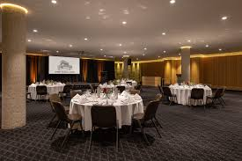friendly gathering with our visiting friends from

overseas and interstate over a meal and conversation

in the Ionic Room at the Sydney Masonic Centre.  
Meals will be pre-ordered in a relaxed pub-style setting.

(menu attached).  
Our Grand Supreme Ruler warmly invites local

Brethren and ladies to attend and help extend a

heartfelt welcome to our guests from other jurisdictions.

**On Saturday 11th October**,

The Installation of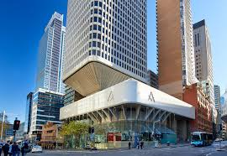 our Grand Supreme Ruler will be

a special occasion not to be missed.

Following the ceremony, join us for a sumptuous

meal accompanied by entertainment, offering the

perfect opportunity to reconnect with old friends

from the past and making new friends.

The Sydney Masonic Centre, our venue for the evening, is celebrated as one of Sydney’s most architecturally significant landmarks - a prime example of the Brutalist style

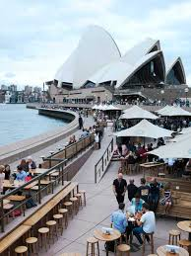

**~~On Sunday 12th October~~** ~~we will gather in the foyer of the Sydney Opera House at 11:00 AM for a guided tour of this iconic landmark~~**~~,~~** ~~followed by a delightful luncheon with wine at the Sydney Opera House Bar, offering stunning views of beautiful Sydney Harbour. (Menu attached.)~~

## **ACCOMMODATION.** Many of our friends attending the Grand Installation have their own favourite accommodation, but for those who would like some suggestions, the following venues are listed:

The Castlereagh Boutique Hotel, (The Masonic Club)

169 Castlereagh St Sydney. 92841000. For savings - book directly with the Club

Vibe Hotel, *111 Goulburn St Sydney. 82723300*.

Ridges Sydney Sq. *389 Pitt St, Sydney. 82681888.*

Hyde Park Inn, *271 Elizabeth St Sydney. Call 92646001 or book on their website “hydeparkinn.com.au” for discount availability.*

**Friday Night Meet and Greet**

**Menu Options**

Choose a plate and place the corresponding Option Number  
 in the column marked “Menu Choice”.

A Vegetarian meal is available on request with sufficient notification.

There will be limited house Red/White wines and Orange Juice available  
along with a cheese platter on each table.

A Credit Card bar will operate for Beer, Spirits and soft drink

Option 1:– Steak and Chips - available GF/DF

Option 2 :- Fish and Chips

Option 3 :- Chicken Parmigiana and Chips – available GF

Option 4 :- Bangers and Mash - available in Lamb, GF

**Sunday Tour & Dine**

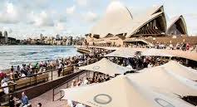

**Opera Bar**

Reflecting the spirit of Sydney, Opera Bar is relaxed and stylish with a sunny disposition that celebrates the seasons and shares local favourites. Fresh, seasonal and sustainable, the menu showcases Australian suppliers and provenance, and seafood is the star.

OPERA BAR TOUR AND DINE MENU  
Choose one meal from the following:

* Roast pumpkin, quinoa, seeds, pomegranate (vgn, gf)
* Beetroot tart, frisée, eschallot, horseradish, crème fraîche  (v)
* Cherry tomato pizza, mozzarella, oregano (v)
* Prawn pizza, spinach, tomato, chilli
* Beer battered fish & chips, tartare sauce (df)
* Grilled half chicken, olives, capsicum, kipfler potatoes (gf, df)
* Beef burger, lettuce, tomato, pickle, cheese, onion, chips
* Pappardelle pasta, beef ragú, ricotta salata, basil

Each meal also includes one drink of either Opera Bar wine, Opera Bar beer, soft drink or juice.

**What to know before you go**

Running time of tour approximately**1+ hours**.

We stage lots of live performances, so venues are subject to availability at the time of your tour.

You’ll be on your feet for a guided tour, there are over 300 stairs, so flat comfortable shoes are recommended. Your feet will thank you!   
Prams and buggies cannot be used on the tour as they are not allowed in our venues.  
Videoing is not allowed. There are plenty of photo opportunities. Your tour guide will advise you if photos are not to be taken at any point.